Video Interface Controller

Version 1.0

SHMT Co., Ltd.

REVISION HISTORY
Version | Detail(굴림/Verdana 10pt bold) | Name | Date
1.0 | Video Interface Controller Spec. Created | East | 2006-12-14

Technical documents
Copyright © 2006 Shmt Limited. All rights reserved.

Confidentiality Status
This document is NOT OPEN ACCESS. The distribution is restricted to certified company.
This document is CONFIDENTIAL.

Feedback on this document
If you have any comments on this document, please contact your channel to our company.

Shmt Web address
http://www.shmt.com

Contents

1. Function Description 7
1.1. Overview 7
1.1.1. Feature 7
1.1.2. Block Diagram 8
1.2. Operation 8
1.2.1. BT656 Video Interface Controller Block 9
1.2.2. AXI BUS Write DMA Interface Block 10
1.2.3. Video Interface Controller Register Interface 11
1.3. Register Description 12
1.3.1. VIF Registers 12
1.3.2. VIF Control Register 13
1.3.3. VIF Interrupt Status Register 14
1.3.4. Video XY Position Register 14
1.3.5. Video XY Size Register 15
1.3.6. Video Write DMA Address Register 15

Figures

Figure 1 AXI Interface Video Interface Controller Top Block Diagram 8
Figure 2 BT656 Video Interface Block Diagram 9
Figure 3 AXI BUS Write DMA Interface Block Diagram 10

Tables
Table 1-1 VIF Registers(Base Address : 1FFF 0000h) 12
Table 1-2 VIF Control Register Description(Offset : 0000 0000h) 13
Table 1-3 VIF Interrupt Status Register Description(Offset : 0000 0004h) 14
Table 1-4 Video XY Position Register Description(Offset : 0000 0008h) 14
Table 1-5 Video XY Size Register Description(Offset : 0000 000Ch) 15
Table 1-6 Video Write DMA Address Register Description(Offset : 0000 0010h) 15

Function Description

Overview

Feature

- Support BT656 Video(NTSC/PAL) Interface.
- Support AMBA3 AXI Write DMA Interface.

Block Diagram

Figure 1 AXI Interface Video Interface Controller Top Block Diagram
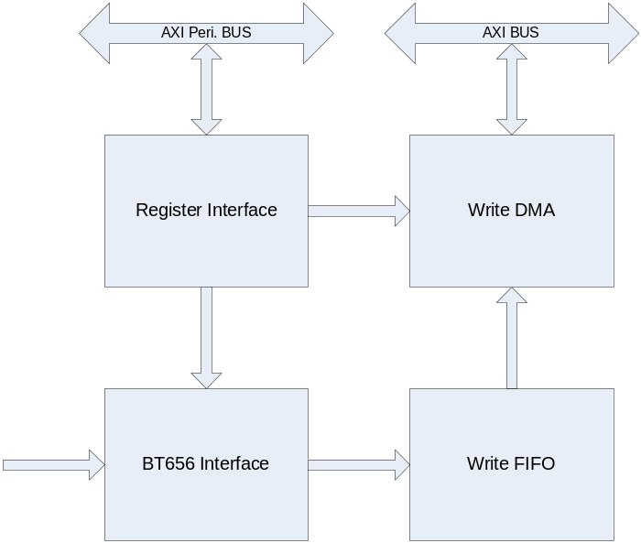

Operation

AXI Interface Video Interface Controller는 3개의 Block으로 나눌 수 있다.
BT656 Interface, Timing 및 Control에 필요한 Register 인터페이스 블록과 AXI BUS Write DMA 인터페이스 블록이다.

BT656 Video Interface Controller Block

외부의 Video Decoder의 Video Clock과 Data를 이용하여 Timing Reference Symbol에서 Field, VSync, HSync에 대한 정보를 얻고, Register Block의 Mask 정보를 가지고 Active Video Data를 Masking할 수 있다.

예를 들어 Active Video Data가 720x480(NTSC)일 경우의 VIFXPos=0, VIFYPos=11, VIFXSize=720, VIFYSize=240(288 at PAL)로 설정하면 입력 Active Video Region은 다음과 같이 Masking 된다.

NTSC : (22~261(even)/285~524(odd)) line
PAL : (23~310(even)//336~623(odd))) line

Mask된 Active Video Data는 FIFO에 저장 된다.

Figure 2 BT656 Video Interface Block Diagram
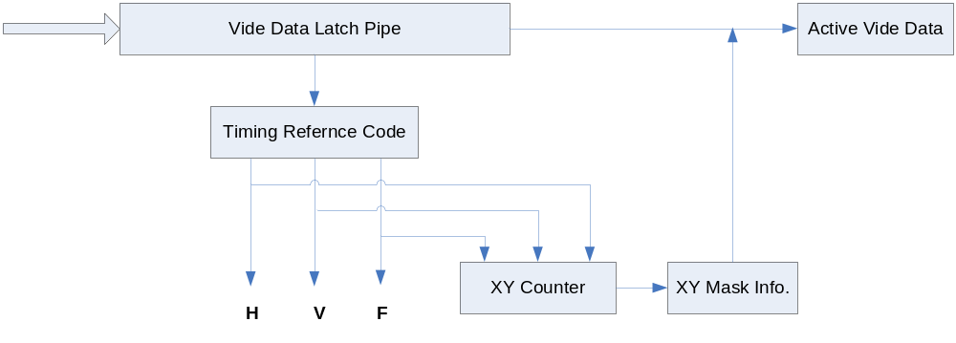

AXI BUS Write DMA Interface Block

AMBA3 AXI Write BUS는 Write Command Channel, Write Data Channel, Write Response Channel 등의 3 채널로 나눌 수 있다.
AXI의 Write Channel의 Timing에 맞게 FIFO에서 Video Data를 Register에서 설정된 개수만큼 읽어 Main Memory에 Write Protocol에 맞추어서 32bit 단위로 Write 한다.

Figure 3 AXI BUS Write DMA Interface Block Diagram
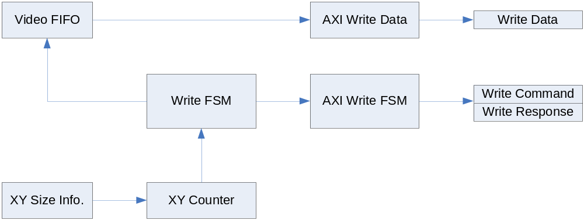

Video Interface Controller Register Interface

BT656 Video Interface Block과 AXI Write BUS DMA Interface 블록이 적절하게 동작 할 수 있는 컨트롤과 정보를 제공하게 된다.

Register Description

VIF Registers

Table 1-1 VIF Registers(Base Address : 1FFF 0000h)
Offset | Name | R/W | Description | Init. value
0000h | VIFCON | RW | VIF Control Register | 0000 0000h
0004h | VIFSTS | RW | VIF Status Register | 0000 0000h
0008h | VIFPOS | RW | Video XY Position Register | 0000 0000h
000Ch | VIFSIZ | RW | Video XY Size Register | 0000 0000h
0010h | VIFADDR | RW | VIF Write DMA Address Register | 0000 0000h

VIF Control Register

Figure 2-1 VIF Control Register Bits
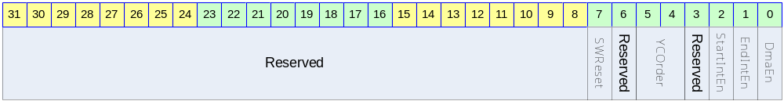

Table 1-2 VIF Control Register Description(Offset : 0000 0000h)
Bits | Name | R/W | Description | Init. value
[31:8] |  |  | Reserved | 0
[10] | HBlank | R | Indicate HBlank
[9] | VBlank | R | Indicate VBlank
[8] | Field | R | Indicate Field  0 : Even Field  1 : Odd Field
[7] | SWReset | RW | Reset VIF Controller  1 : Reset  0 : Set | 0
[6] |  |  | Reserved
[5:4] | YCOrder | RW | YCbCr Order  MSB/ ~ /LSB  0b00 : Cr0/YY1/Cb0/YY0  0b01 : Cb0/YY1/Cr0/YY0  0b10 : YY1/Cb0/YY0/Cr0  0b11 : YY1/Cr0/YY0/Cb0 | 0
[3] |  |  | Reserved | 0
[2] | StartIntEn | RW | Frame(field)의 전송이 시작되면 매 even field 마다 인터럽트를 걸지 여부를 결정한다.  DMA Address Change 용도로 사용할 수 있다.  0 : Frame Start Interrupt Disable  1 : Frame Start Interrupt Enable | 0
[1] | EndIntEn | RW | Frame(field)의 전송이 종료되면 인터럽트를 걸지 여부를 결정한다.  0 : Frame End Interrupt Disable  1 : Frame End Interrupt Enable | 0
[0] | DmaEn | RW | DMA Enable  0 : DMA Disable  1 : DMA Enable | 0

VIF Interrupt Status Register

Figure 2-2 VIF Interrupt Status Register Bits
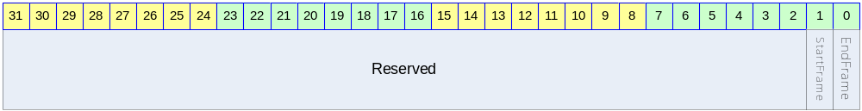

Table 1-3 VIF Interrupt Status Register Description(Offset : 0000 0004h)
Bits | Name | R/W | Description | Init. value
[31:2] |  |  | Reserved | 0
[1] | StartFrame | R | Start of Frame  When Read, Auto Cleared to zero | 0
[0] | EndFrame | R | End of Frame  When Read, Auto Cleared to zero | 0

Video XY Position Register

Figure 2-3 Video XY Position Register Bits
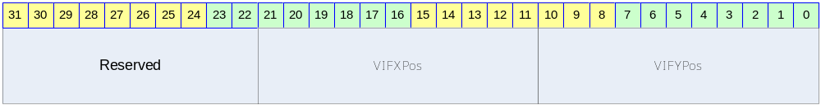

Table 1-4 Video XY Position Register Description(Offset : 0000 0008h)
Bits | Name | R/W | Description | Init. value
[31:22] |  |  | Reserved | 0
[21:11] | VIFXPos | RW | X Position Start : X position of top left corner of Bt656 Input Video | 0
[10:0] | VIFYPos | RW | Y Position Start : Y position of top left corner of Bt656 Input Video | 0

Video XY Size Register

Figure 2-4 Video XY Size Register Bits
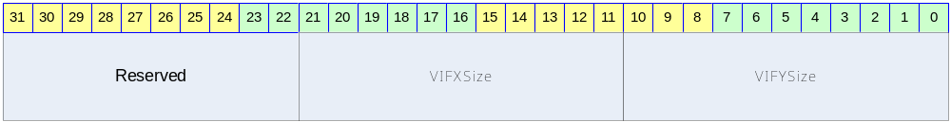

Table 1-5 Video XY Size Register Description(Offset : 0000 000Ch)
Bits | Name | R/W | Description | Init. value
[31:22] |  |  | Reserved | 0
[21:11] | VIFXSize | RW | BT656 Input Video Surface Width | 3ffh
[10:0] | VIFYSize | RW | BT656 Input Video Surface Height | 3ffh

Video Write DMA Address Register

Figure 2-5 Video Write DMA Address Register Bits
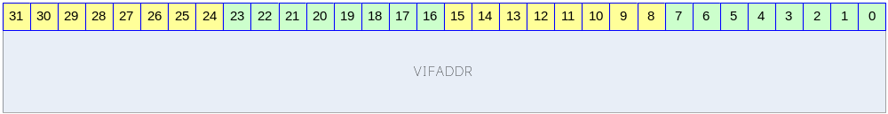

Table 1-6 Video Write DMA Address Register Description(Offset : 0000 0010h)
Bits | Name | R/W | Description | Init. value
[31:0] | VIFADDR | RW | VIF Write DMA Address  32bit Aligned Address → 하위 2 bit는 ‘0’ 로 고정해서 설정해야 한다. | 0

